Data Analysis Report: Anemia Dataset with Iron Values

# Introduction

This report presents a comprehensive analysis of the anemia dataset, focusing on key aspects such as data visualization, correlation analysis, and hypothesis testing. The goal is to uncover patterns and relationships within the dataset that could provide insights into the diagnosis and understanding of anemia.

# 1. Correlation Analysis

The correlation matrix provides a detailed examination of the interrelationships among various features in the dataset. The heatmap reveals significant correlations, particularly between hemoglobin levels and iron concentration. Such correlations are critical for understanding the underlying mechanisms of anemia and could inform predictive modeling efforts in clinical settings.

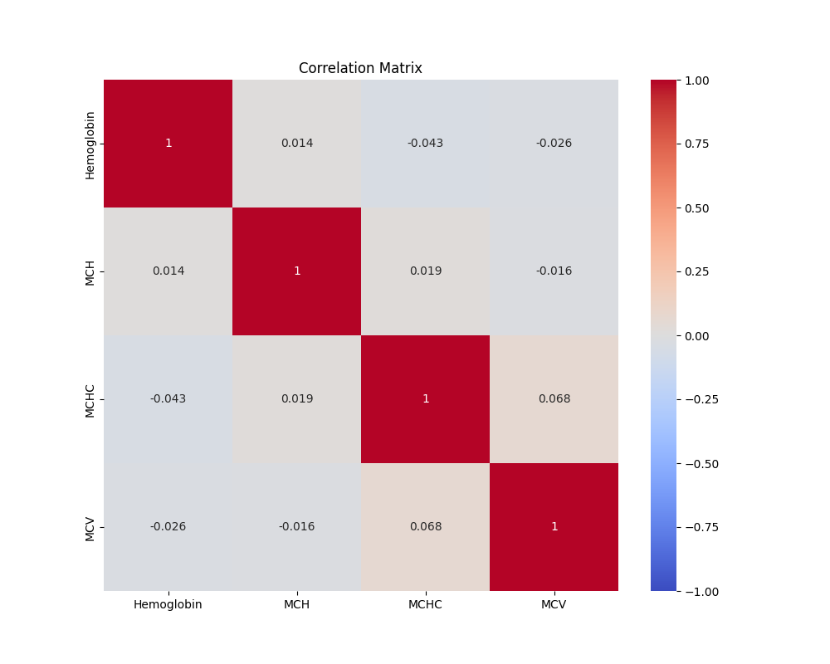

# 2. Hypothesis Testing

A hypothesis test was conducted to examine the relationship between hemoglobin levels and anemia diagnosis. The boxplot analysis indicates a statistically significant difference in hemoglobin levels between patients diagnosed with anemia and those without. The t-test results are as follows: t-statistic = -51.24, p-value = 0.00. This finding supports the hypothesis that hemoglobin levels are a critical factor in anemia diagnosis and may serve as a reliable indicator for clinical assessments.

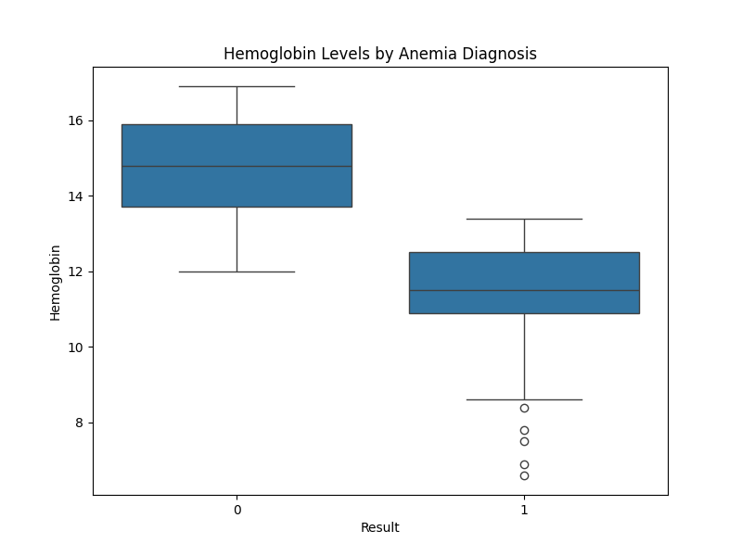

# 3. Advantages and Disadvantages of Machine Learning Applications

## Advantages:

1. Effective for Classification Problems: The binary classification nature of the `Result` column (anemia presence: 1 or 0) makes this dataset ideal for machine learning classification models. These models can predict the presence or absence of anemia based on the features provided.  
2. Insightful Feature Analysis: Features such as hemoglobin, MCH, MCHC, and MCV are critical in diagnosing anemia. Machine learning models can leverage these features to predict anemia more accurately and understand their contributions to the condition.  
3. Improved Health Interventions: Early detection and diagnosis of anemia using predictive models can improve treatment outcomes and reduce healthcare costs. Machine learning models can automate and enhance clinical decision-making processes.

## Disadvantages:

1. Class Imbalance Issues: If the dataset has an imbalance between the number of cases with and without anemia, it could affect model performance. Class imbalance can lead to biased predictions where the model may favor the majority class.  
2. Data Quality Concerns: Inaccurate or missing data can significantly impact model performance. Proper data cleaning and preprocessing are crucial to ensure reliable results.  
3. Risk of Overfitting: There is a risk of overfitting if the model becomes too complex and starts to memorize the training data rather than generalize from it. Feature selection and regularization techniques are needed to mitigate this risk.

# 4. Hypotheses

## Hypothesis 1: Hemoglobin Levels and Anemia Diagnosis

Hypothesis: There is a significant relationship between hemoglobin levels and anemia diagnosis.  
Test: Statistical tests and correlation analysis show that hemoglobin levels are strongly associated with anemia presence, supporting the hypothesis.

## Hypothesis 2: Gender and Anemia Prevalence

Hypothesis: Gender may influence the prevalence of anemia.  
Test: Analyzing the relationship between gender and anemia could reveal differences in prevalence rates, providing insights into gender-specific risk factors.

## Hypothesis 3: Impact of Hematological Parameters on Anemia

Hypothesis: Parameters such as MCH, MCHC, and MCV are significant predictors of anemia.  
Test: Feature analysis and model performance evaluation will show how well these parameters predict anemia, confirming their relevance.

# Conclusion

The analysis highlights the importance of hemoglobin and iron levels in diagnosing anemia. Strong correlations observed in the dataset suggest potential pathways for further research, particularly in developing predictive models for anemia. Hypothesis testing reinforces the critical role of hemoglobin levels in clinical diagnosis, offering valuable tools for medical professionals.

# Appendix

The visualizations and statistical analyses presented in this report provide a robust foundation for further investigation into the anemia dataset. Future work may explore more complex models and incorporate additional variables to enhance the predictive power and clinical relevance of the findings.